**“E-KETHA” : ENRICHING RICE FARMER’S QUALITY OF LIFE THROUGH A MOBILE APPLICCATION.**

2022-81

Project Proposal Report

K.M.Umesh Ranthilina

B.Sc. (Hons) Degree in Information Technology

Department of Computer Science and

Software Engineering

Sri Lanka Institute of Information Technology

Sri Lanka

February 2022

**“E-KETHA” : ENRICHING RICE FARMER’S QUALITY OF LIFE THROUGH A MOBILE APPLICCATION.**

2022-81

Project Proposal Report

K.M.Umesh Ranthilina – IT19240152

Supervisor: Mr. Adeepa Gunarathna

Co Supervisor: Ms. Amali Upeka Gunasinghe

B.Sc. (Hons) Degree in Information Technology

Department of Computer Science and

Software Engineering

Sri Lanka Institute of Information Technology

Sri Lanka

February 2022

**Declaration, Copyright Statement and The Statement Of The Supervisor**

We declare that this is our own work and this proposal does not incorporate without acknowledgement any material previously submitted for a degree or diploma in any other university or Institute of higher learning and to the best of our knowledge and belief it does not contain any material previously published or written by another person except where the acknowledgement is made in the text.

|  |  |  |
| --- | --- | --- |
| Name | Student ID | Signature |
| K.M.Umesh Ranthilina | IT19240152 |  |

The supervisor/s should certify the proposal report with the following declaration.

The above candidates are carrying out research for the undergraduate Dissertation

under my supervision.

------------------------------ ------------------------------

Signature of the supervisor: Date:

------------------------------ ------------------------------

Signature of the supervisor: Date:

# ABSTRACT

In our country of Sri Lanka, rice is the most common type of food that is consumed in a daily basis. Due to that rice farmers face a huge amount of stress to supply according to the massive demand. Identifying the growth of the paddy plant in the field of paddy cultivation is one of the most important roles in the field of paddy cultivation. The growth of paddy seedlings is a natural process and if proper care is not taken in this area it can cause severe growth retardation of paddy plants. Therefore it affects the productivity, quantity, and quality of paddy products. Some other reasons for paddy retardation are diseases, lack of water, and fertilizer not only limiting the growth of the plant but also reducing the yield of paddy and destroying it. Therefor it is necessary to identify the cause of growth reduction. Image processing is used to measure the growth of the paddy plant and the reason for the defect while machine learning will give the most suitable solution.

 Keywords :- machine learning, image processing, deep learning, rice crop, height, paddy plant

# TABLE OF CONTENTS

ABSTRACT iv

TABLE OF CONTENTS v

LIST OF FIGURES vi

LIST OF TABLES vi

1. INTRODUCTION 1

**1.1** **Background** 1

**1.1.1 Why rice height is important?** 2

**1.2 Literature Survey** 3

**1.2.1 Rice Crop Height Measurement Using a Digital Image Processing** 3

**1.2.2 Measurement of crop height using UAV-Based Lidar** 4

**1.2.3 Measurement of plant heights in an agricultural field using a time-lapse camera** 4

**1.2.4 Measurement of heights of rice and tiller fragmentation of rice crops** 4

**1.3 Research Gap** 5

**1.4** **Research Problem** 5

**2.** **OBJECTIVES** 6

**2.1 Main Objectives** 6

**2.2 Specific Objectives** 6

3. METHODOLOGY 7

**3.1 Height Identification Of The Rice Plants** 7

**3.2 Research Area** 8

**3.3 Requirement Gathering And Analyzing** 8

**3.4.1 functional requirements** 8

**3.4.2 Non-functional requirements** 8

**3.5 Design** 9

**3.6 Tools And Technologies** 9

**3.6.1 Tools** 9

**3.6.2 Technologies** 9

**3.7 Implementation** 9

**3.8 Testing And Maintenance** 10

**3.9 WBS** 10

**3.10 Grant Chart** 11

4. DESCRIPTION OF PERSONAL AND FACILITIES 12

5.BUDGET 13

References 14

# LIST OF FIGURES

Figure 1:Rice plant growth lifecycle 1

Figure 2:Rice age and growth 2

Figure 3 : Paddy production in Sri Lanka 3

Figure 4:Growth tracker overview 7

Figure 5:WBS chart 10

Figure 6:Grant chart 11

# LIST OF TABLES

Table 1:Comparing existing application and our application features 5

Table 2:4. DESCRIPTION OF PERSONAL AND FACILITIES 12

Table 3:Budget 13

# INTRODUCTION

## **Background**

One of the staple food in Sri Lanka is the common rice that can be farmed in paddy fields. Due to various reasons farmers find it difficult to reach the demand quota. One particular reason for this is the issues when it comes to the growth of rice plants.

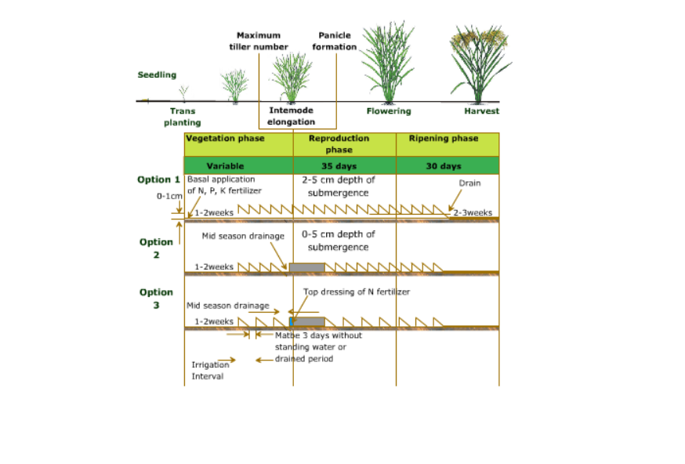

Figure 1:Rice plant growth lifecycle

As it is shown in the above figure 1 [7] there are many different lifecycle stages when it comes to rice plant. These phases can vary according to the rice plant. Since the proper treatment and needs of the rice plant changes frequently it could be difficult to properly treat them. Due to this, farmers lose much produce and profit.

### **1.1.1 Why rice height is important?**

Plant height is a central part of the plant ecosystem strategy. It is closely related to lifespan, seed mass, and time to maturity, and is a key determinant of a species' ability to compete for light. Plant height is also associated with critical ecosystem variables such as animal diversity and carbon storage capacity. However, global patterns of plant height are significantly smaller. The most effective metric height is when measuring the growth of rice plants. This is because height is the clearest and most concise way to tell a particular plant stage

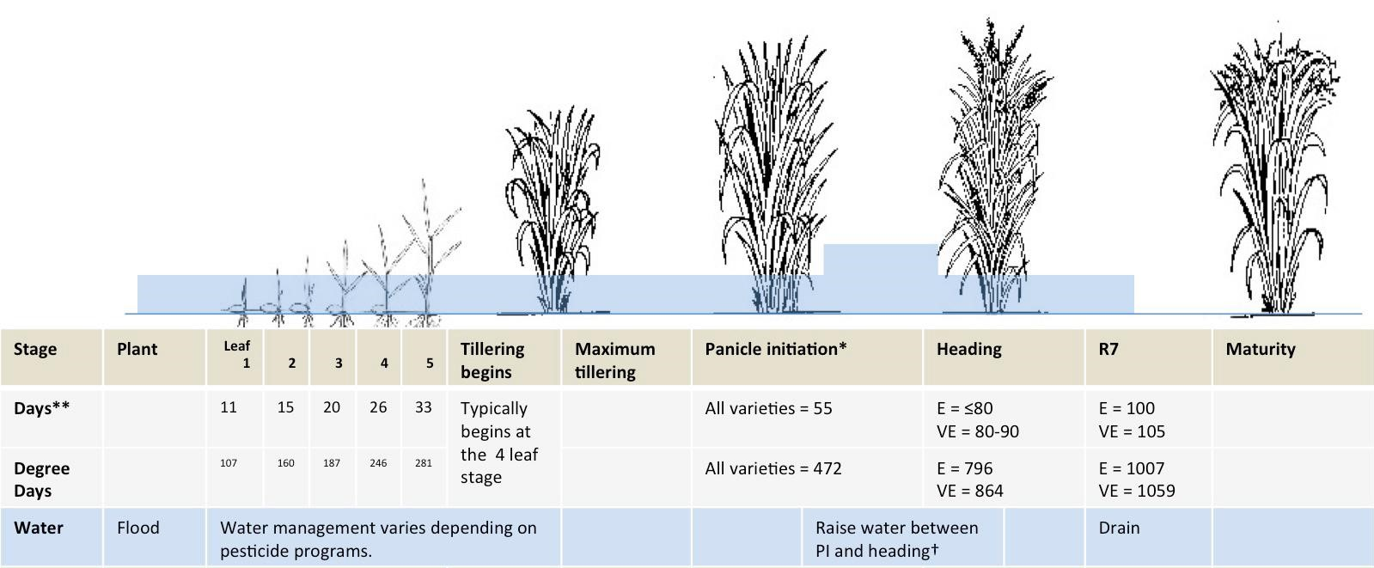

Figure 2:Rice age and growth

As it shown in the about figure 2 [6] it is clearly evident that to get maximum harvest out of the crop proper growth necessary. To identify the best harvesting we need to identify the stage that the plant is in. In order to know the stage the no of days are also a necessity.

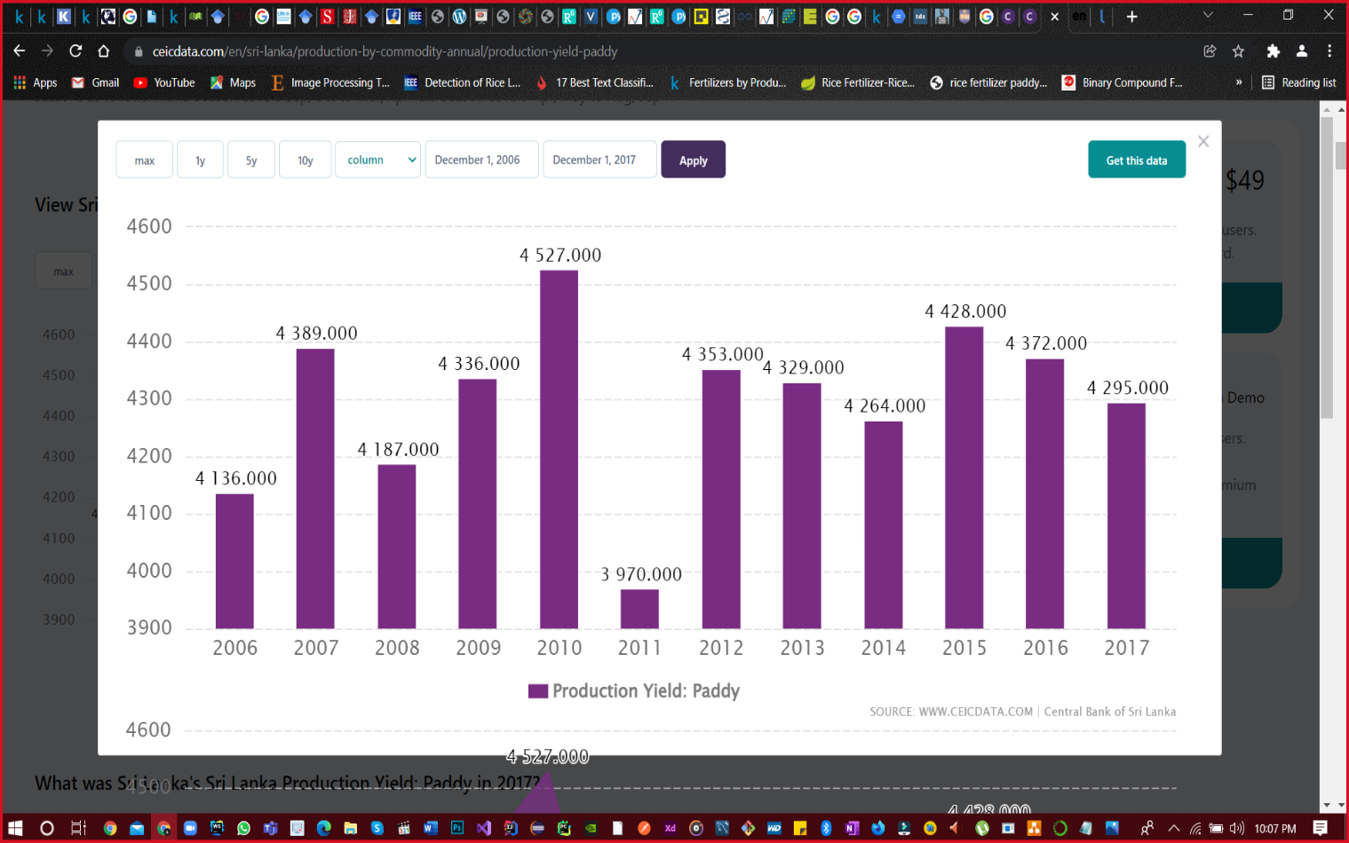

Figure 3 : Paddy production in Sri Lanka

This figure 3 [8] shows the rice production in Sri Lanka throughout the years starting from 2006 – 2017. Excluding the year 2011 where the paddy production was halted due to natural disasters [9], we can see a downward trend when the timeline gets nearer. According to the traditional farmers opinion the reason dwindled into the mis management of paddy crops during its growth.

## **1.2 Literature Survey**

### **1.2.1 Rice Crop Height Measurement Using a Digital Image Processing**

This is a plant height identification method currently in operation in Thailand. It detects the height of the plant and shows the height of the plant to the user. But it does not use a mobile app.

Here is an automatic image processing method to identify the user based on the photos taken by a digital camera mounted on a field server, including a marker bar used to describe the height of the rice plant. Height can be estimated by analyzing the uploaded image obtained by the user. Here the marker bar is used to measure the height of the rice crop and compare it with the starting point. Further, digital image processing for analysis uses four steps to automatically measure rice crop height. So you can get the height of the rice tree [3].

### **1.2.2 Measurement of crop height using UAV-Based Lidar**

This is an application based on finding height measurements. It is considered by many plants, but not so for paddy plants. You are a farmer and it is important to conceptualize crops because of the increasing pressure on food production. Therefore, an accurate assessment of biomass during the growing season is important to optimize yield.

Therefore, UAV-LiDAR examined data availability for estimating fresh biomass and crop height for three different cultivars (potatoes, sugar beets, and winter wheat). This was done using the algorithm 3DPI to estimate the crop height using the mean height of the highest point variable number of the plant.

It does not use a mobile application for height measurement, and for maximum efficiency, it uses RGB cameras mounted on a vehicle's LiDAR-based system or UAV (unmanned aerial vehicle), plant height, LAI, and leaf cover section. Such characteristics are determined directly in the field [1] [2]

.

### **1.2.3 Measurement of plant heights in an agricultural field using a time-lapse camera**

This is an application used to measure plant height with adequate temporal and spatial resolution. This is a low cost and easy to use method for height search. Here the use of a camera is to capture seasonal and year-to-year variations in plant height that represent plant height on a site scale. This method was used to determine the height of the plant up to the nearest 1 cm from the camera images by pointing a certain scale strip at a particular field.

The obtained plant heights were corrected for vertical distortions and a good agreement on plant height was obtained by comparing them with direct height measurements for each of the target plants and site-scale plant heights averaged from the 10 samples. It does not use a mobile application and image processing but uses a sensor and a digital camera [4].

### **1.2.4 Measurement of heights of rice and tiller fragmentation of rice crops**

This research is done by accessing the height and tiller count which is necessary for accessing a plant’s phenotype. The automation of phenotyping recommended here makes it so that manual visual assessment it not needed due to the highly accurate, reproductive, and traceable image processing.

By applying HSV and thresholding for processing, Canny Edge Detection (tiller) and Zhang-Suen Thinning Algorithm (height) for the plant structure and the Euclidean Distance for measuring the height, tiller counting is done. 17.25% for height and 34.02% for tiller count were found during the testing and this may be cause of plant not able to fit the frame. This may be also cause of yellow leaves remove done during processing [5].

## **1.3 Research Gap**

|  |  |  |  |  |  |
| --- | --- | --- | --- | --- | --- |
| **Features** | 1.2.1 | 1.2.2 | 1.2.3 | 1.2.4 | E-Ketha |
| Height measurement | **✓** | **✓** | **✓** | **✓** | **✓** |
| Growth phase deduction | **✓** | **🗶** | **🗶** | **🗶** | **✓** |
| Aerial Imagery Used | **🗶** | **✓** | **🗶** | **🗶** | **✓** |
| classify rice plant height | **🗶** | **🗶** | **✓** | **🗶** | **✓** |
| Propose Solution on how to growth of the plant | **✓** | **🗶** | **✓** | **🗶** | **✓** |

Table 1:Comparing existing application and our application features

## **Research Problem**

Rice productivity is highly dependent on the Sri Lankan economy. Now a days paddy growers are moving away from paddy cultivation. The main reason for this is that they are not able to earn a fair income. This is a major problem in paddy cultivation.

The growth that affected rice plants is one of the major problems in paddy cultivation. Paddy growers lose a large percentage of their annual paddy harvest due to a lack of knowledge about the growth of paddy cultivation. Farmers are not aware of the process of increasing the growth of paddy. Also, due to the lack of support from technology, the younger generation is moving away from paddy cultivation.

So the solution is to create a mobile application that works in parallel to these major problems in paddy cultivation. Using this application, paddy growers can gain knowledge about their growth of paddy cultivation and how to uplift profit

## **OBJECTIVES**

### **2.1 Main Objectives**

The main objective of identifying the growth of paddy plants is to create an Android-based mobile application that analyzes the changes in the paddy tree using image processing technology and tracks the height of the paddy tree. The Mobile-based application is used to identify the height of a paddy tree with the help of an automated algorithm. The algorithm uses the database to identify the most vulnerable and predict the most accurate outcome. In addition, the application provides treatment to a paddy grower to increase the growth of paddy cultivation.

### **2.2 Specific Objectives**

01 The application identifies the growing height of the rice plant by analyzing the changes in the growth of the paddy plant.

The paddy grower uses a mobile phone at a specified distance from a rice plant to take an image and upload it through the application using image processing technology. The application compares the height changes of a paddy plant with the data uploaded in the database and identifies whether the paddy plant has grown or not.

02 Application Rice plants are classified according to their height.

Once the height scale is successfully identified, the rice plant is classified according to its growing size. There are stages of good, normal, low and so on.

03. The application will treat according to height type and the current status of height.

The application will suggest treatments to enhance the growth of the paddy plant to the identified heights

# METHODOLOGY

This section will entail the details on the techniques and mechanisms that are employed to create the Growth Detection component, belonging to the “e-ketha” application from the data gathering stage all the way to implementation. Details include how the software will be used in our project what materials and data will be required, and how they will be collected.

## **3.1 Height Identification Of The Rice Plants**

Height affects the growth of paddy. Growth for height has a life cycle of several different loves. These include seeding, transplanting, maximum tillering, panicle formation, flowering, and harvesting. Many farmers have no knowledge of growth.

Therefore create a database on paddy cultivation using data excavation techniques and model analysis. The training database is retrieved with the information provided by the user. The user uploads the tall image of the paddy plant to the mobile application system and at the same time takes the date and time as user input. The image is then analyzed and the result obtained with the date and time obtained from the user identifies how much the rice tree height has increased with the database. If it is identified as low growth, it will show the treatment methods required for paddy cultivation. The height of the paddy tree must be accurately identified for this process. The height of the paddy tree should be taken at a specific distance. Image processing, machine learning, and deep learning techniques are used for this process to give the possible solution so as to improve the growth rice plant.

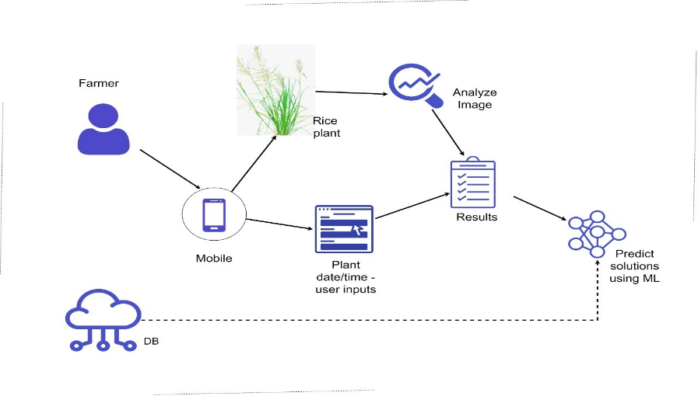

Figure 4:Growth tracker overview

## **3.2 Research Area**

When it comes to research area, four features were identified. Such as Image processing activities, Classification activity, Detection activities and finally solution prediction. In order to conduct the research, deep learning technology has been taken as the core foundation.

## **3.3 Requirement Gathering And Analyzing**

Due to the importance of requirement gathering and analysis, major emphasis was put to this section. Since there is a need for this process to be strictly on the “Identification of growth deficiency and solution finding” part below mentioned approaches were used.

* Reading research papers relevant to the research problem.
* Studying existing systems related to our research area.
* Contacted experts in Rice Research and Development Institute(RRDI) , Bathalagoda.
* Met with Sri Lankan paddy farmers.

To get an idea about the research problem, studying related research papers are a must. Next step was to understand what types of systems that already exists, so as to see what are lacking and needs improvements. Finally to see if the proposed solution is viable in the current environment, specialists on the field and traditional farmers were contacted.

### **3.4.1 functional requirements**

* Ability to upload rice crop imagery.
* Identify the height of the plant.
* Calculate the growth.
* Propose solutions.
* Show proposed solutions.

### **3.4.2 Non-functional requirements**

* Reliability
* Accuracy
* Availability
* Performance
* User friendly

## **3.5 Design**

Design phase encompasses what is needed for the estimation of hardware and system requirements by the creation of a system architecture, due to the needs and specifications being included. The architecture will entail the components separated into manageable levels according to the respective research project member. In this case it will be the “Identification of growth deficiency and proposing solutions” component.

## **3.6 Tools And Technologies**

### **3.6.1 Tools**

* Android studio
* PyCharm
* OpenCV
* Jupiter notebook
* DB

### **3.6.2 Technologies**

* Machine learning/Deep learning
  + CNN
* Image processing
* Android – java
* Python

## **3.7 Implementation**

In this stage of the project, the implantation of the system will be started. This will be in accordance with the system architecture proposed in the previous design phase. “Identification of growth deficiency and proposing solutions” component will be further split into three subcomponents, with them being

* Identify the height of the plant using imagery
* Proposing solutions.

## **3.8 Testing And Maintenance**

As the final phase of the Software development life cycle(SDLC) is the testing and maintenance phase which will be done under the disciplines of functional and nonfunctional testing. The functional testing will mainly consider the functional requirements of the system and unit testing will be taken as the basis. Then in order to check the nonfunctional requirements such as performance and availability various nonfunctional testing will be conducted. As for the maintenance of the application after the publication various support features will be added.

## **3.9 WBS**

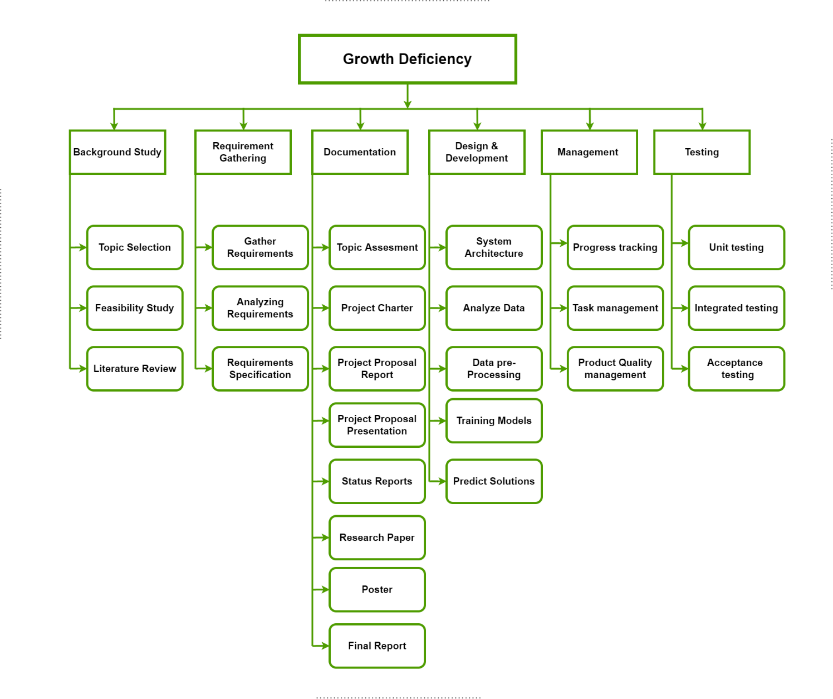

Figure 5:WBS chart

## **3.10 Grant Chart**



Figure 6:Grant chart

# DESCRIPTION OF PERSONAL AND FACILITIES

|  |  |  |
| --- | --- | --- |
| **Student Details** | **Role** | **Tasks** |
| IT19240152 | Group Member | Upload/capture rice plant image.  Detecting the rice plant that needs to measure growth by using the image.  Detect and calculating the rice plant height.  Identify if there are any deficiency by using the height.  Suggesting appropriate solutions in order to manage rice plant growth efficiently. |

Table 2:4. DESCRIPTION OF PERSONAL AND FACILITIES

# 5.BUDGET

Table 3:Budget

# References

|  |  |
| --- | --- |
| [1] | Z. Lei, T. E and G. , "A LIDAR-Based Crop Height Measurement System for Miscanthus Giganteus," *Computers and Electronics in Agriculture,* pp. 70-76, 2012. |
| [2] | t. Harkel and J. , "Biomass and Crop Height Estimation of Different Crops Using UAV-Based Lidar," *Remote Sensing,* vol. 12, p. 17, 2019. |
| [3] | S. and T. , "Automatic Rice Crop Height Measurement Using a Field Server and Digital Image Processing," *Sensors ,* vol. 14, pp. 900-926, 2014. |
| [4] | M. MANO, "Precise and Continuous Measurement of Plant Heights in an Agricultural Field Using a Time-Lapse Camera," *Journal of Agricultural Meteorology,* vol. 73, pp. 100-108, 2017. |
| [5] | C. and K. Paulette, "Towards an Automated Plant Height Measurement and Tiller Segmentation of Rice Crops Using Image Processing," Semantic Scholar, 2018. [Online]. Available: https://www.semanticscholar.org/paper/Towards-an-Automated-Plant-Height-Measurement-and-Constantino-Gonzales/130b9345f61bd73b896b9c021a93957c6030b786. [Accessed 24 01 2022]. |
| [6] | University of California, Division of Agriculture and Natural, "Crop Development," University of California, Division of Agriculture and Natural, [Online]. Available: https://rice.ucanr.edu/Crop_Development/. [Accessed 24 01 2022]. |
| [7] | knowledgebank, knowledgebank, [Online]. Available: www.knowledgebank.irri.org/ewatermgt/courses/course1/popups/ricestage.html. [Accessed 24 01 2022]. |
| [8] | ceicdata, "Sri Lanka Paddy: Production: by District," ceicdata, [Online]. Available: https://www.ceicdata.com/en/sri-lanka/paddy-production-by-district. |
| [9] | The guardian, "Sri Lankan floods could leave 400,000 children without enough food," The guardian, [Online]. Available: https://www.theguardian.com/world/2011/jan/20/sri-lanka-floods-children-food. |